Fig. S1

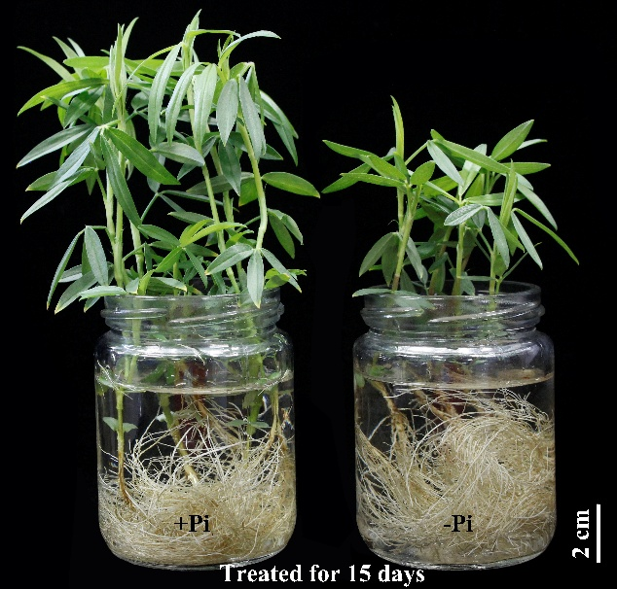

Additional file 1: Fig. S1 Growth performance of stylo at two P levels. Plants were grown in hydroponics for 15 d with (+Pi) or without (−Pi) 250 μmol/L KH₂PO₄ addition. Each bottle contained six plants.

Fig. S2

(a) Total root length
Ratio of increase under -Pi (%)
7
10
15
20
a
b
b
b
F = 6.072
P = 0.004
(b) Root surface area
Treatment times (day)
a
b
b
b
F = 6.072
P = 0.004
7
10
15
20
(c) Root volume
ab
b
a
b
F = 2.781
P = 0.068
7
10
15
20

Additional file 1: Fig. S2 Effects of Pi availability on the ratio of root increase. (a) Total root length. (b) Root surface area. (c) Root volume. After precultured under +Pi (250 μmol/L K₂HPO₄) for 7 d, stylo seedlings were transferred into nutrient solution with (+Pi) or without (−Pi) 250 μmol/L KH₂PO₄ additions for 7, 10, 15, 20 d. Each bar represents the mean of four replicates with SE (n = 6). Different lowercase letters indicate significant difference among groups (P < 0.05). Ratio of increased under −Pi (%) = [(−Pi − +Pi)/+Pi] * 100.

Fig. S3
Ratio of root/shoot
+Pi
−Pi
(day)

Additional file 1: Fig. S3 R Ratio of root/shoot in stylo at two P treatments. Uniform 7-d old stylo seedling were transferred into nutrient solution with (+Pi) or without (−Pi) 250 μmol/L KH₂PO₄ additions for 15 d. Asterisks represent significant differences between +Pi and −Pi treatments. * P ≤ 0.05, ** P ≤ 0.01, *** P ≤ 0.001.

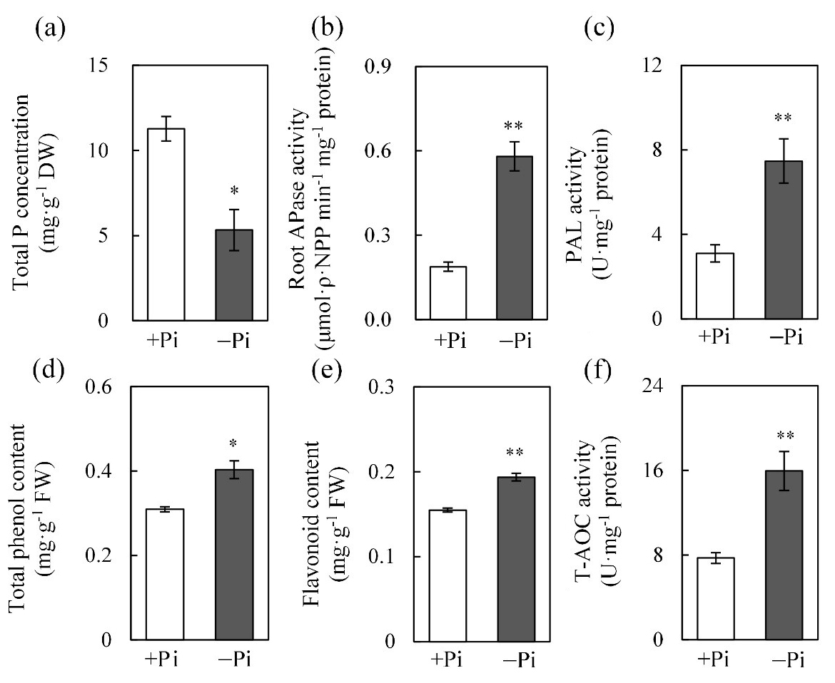
Fig. S4

Additional file 1: Fig. S4 Physiological and biochemical levels in response to low P stress in stylo roots. (a) Total P concentration of shoot and root; (b) APase activity; (c) PAL activity; (d) total phenol content; (e) flavonoid content; (f) T-AOC activity. Stylo seedlings were precultured in hydroponics for 7 d with 250 μmol/L KH₂PO₄ and subsequently transferred into nutrient solution with (+Pi) or without (−Pi) 250 μmol/L KH₂PO₄ additions for 15 d. Each bar represents the mean of four replicates with SE (n = 3 or 4). Asterisks represent significant differences between +Pi and −Pi treatments. * P ≤ 0.05, ** P ≤ 0.01. P: phosphate, APase: acid phosphatase, T-AOC: total antioxidant capacity, PAL: phenylalanine ammonia lyase, DW: dry weight, FW: fresh weight.

Fig. S5

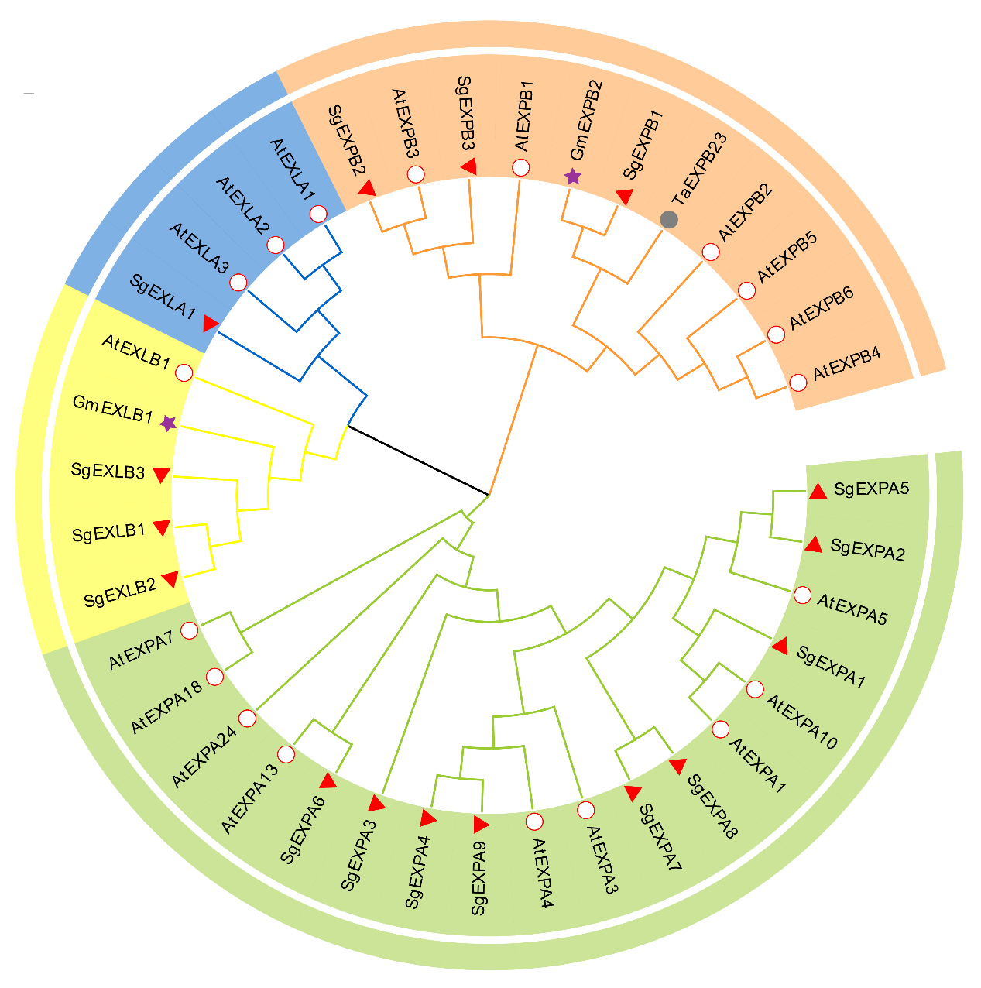
EXPA
EXLA
EXPB
EXLB

Additional file 1: Fig. S5 Phylogenetic analysis of stylo expansin proteins with other expansin proteins in plants. At: Arabidopsis thaliana; Gm: Glycine max; Ta: Triticum aestivum; Sg: Stylosanthes guianensis. EXPA: α-expansin; EXLA: expansin-like A; EXPB: β-expansin; EXLB: expansin-like B.

Fig. S6

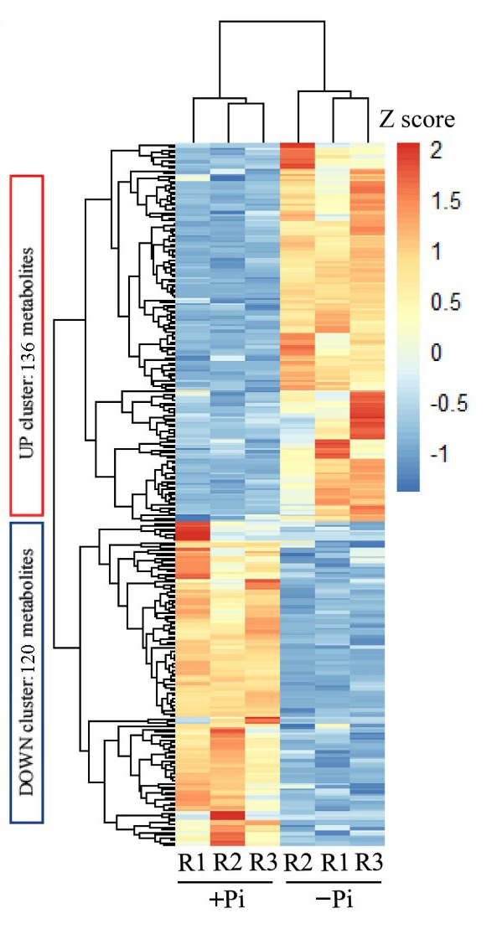

Additional file 1: Fig. S6 Clustered heatmap of differentially accumulated metabolites (DAMs) in stylo roots at low P stress. Individual metabolites are represented by rows and nutritional status are represented by columns. Heatmap visualization of metabolites is based on standardized transformation (Z score) of metabolite concentrations.

Fig. S7

+Pi
−Pi
Relative expression levels

Additional file 1: Fig. S7 Expression analysis of SgPAPs and SgRNSs genes in response to Pi starvation. Expression of five SgPAPs and four SgRNSs in stylo roots exposed to +Pi (250 μmol/L KH2PO4) or −Pi (no KH2PO4 added) treatments for 15 d. Each bar represents the mean of four replicates with SE (n = 4) Asterisks indicate significant differences between +Pi and −Pi treatments. * P ≤ 0.05, ** P ≤ 0.01, *** P ≤ 0.001. ns indicates no significant difference.

